**COMPUTER SCIENCE SEMESTER 2 PART 2 ________________________________________________________________________________________________________________________________________________________TASK 3 (10% CARRYMARKS) SQL EXERCISE : LIBRARY DATABASE**

1. Creating database

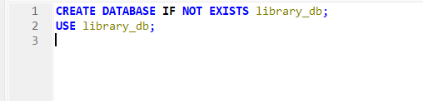

2) Creating books table

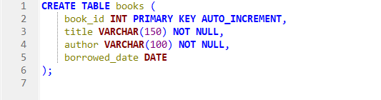

3) Insert 5 books

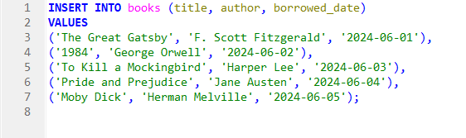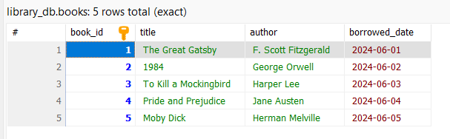

4)List All Books

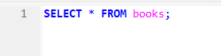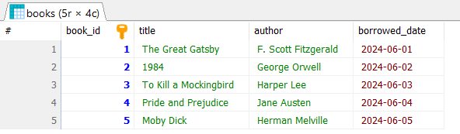

5)Find Books by Author

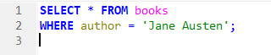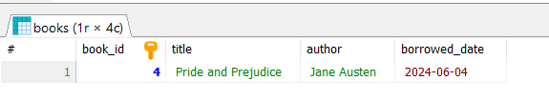

6)Find Books Borrowed on a Specific Date



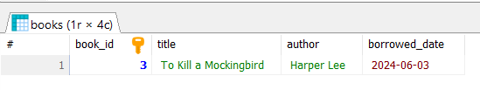

7) Find Books Borrowed After a Certain Date

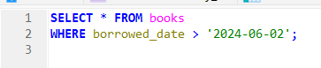

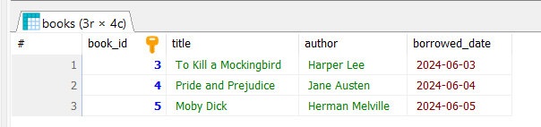

8) Update borrowed_date for a Book

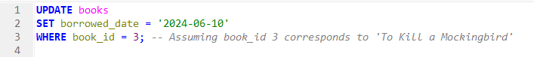

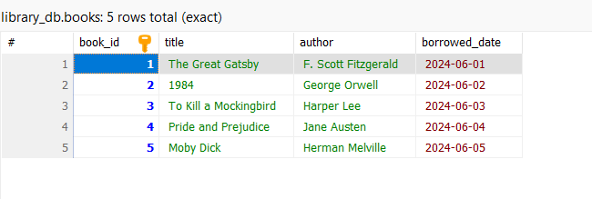

9) Delete a Book

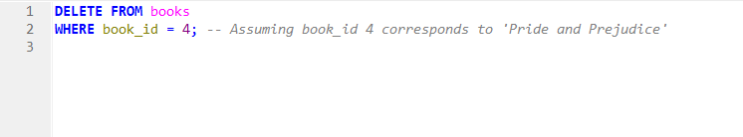

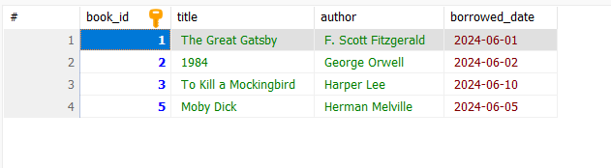

10) Re-Add the Deleted Book

